ASSIGNMENT : 4
1.
Download a sample IAM policy JSON (for example, from AWS documentation), identify all users and their permissions, and list any permissions that are broader than necessary for typical user actions.
ANS :
AWS IAM Policy Analysis
1. Objective
To analyze a sample AWS IAM policy JSON, identify its permissions, and find permissions that are broader than necessary.
2. Sample IAM Policy JSON
{
"Version": "2012-10-17",
"Statement": [
{
"Sid": "ListObjectsInBucket",
"Effect": "Allow",
"Action": ["s3:ListBucket"],
"Resource": ["arn:aws:s3:::bucket-name"]
},
{
"Sid": "AllObjectActions",
"Effect": "Allow",
"Action": "s3:*Object",
"Resource": ["arn:aws:s3:::bucket-name/*"]
}
]
}
3. Identification of Users and Permissions
The policy does not specify individual users by name. It applies to the IAM user, group, or role to which it is attached.
- s3:ListBucket: Allows listing objects in the specified S3 bucket.
- *s3:Object: Allows multiple object-related actions, including uploading, downloading, and deleting objects.
- Effect: Allow: Permits the specified actions, subject to other applicable policies.
- Resource: Specifies the bucket and its objects to which the permissions apply.
4. Permissions Broader Than Necessary
The s3:*Object wildcard grants multiple object-related permissions that may not be necessary for every user. For example, a user who only uploads files may not need permission to download or delete objects. The s3:ListBucket permission may also be unnecessary if the user does not need to list the bucket's contents.
5. Recommended Improvements
The policy should follow the principle of least privilege. Replace broad wildcard permissions with specific actions required for the user's work. For example, s3:GetObject and s3:PutObject are suitable when a user needs to download and upload objects. Grant s3:DeleteObject only when deletion is required, and retain s3:ListBucket only when listing objects is necessary.
6. Conclusion
The sample AWS IAM policy was analyzed to identify its permissions and potentially excessive access. Applying the principle of least privilege helps reduce unnecessary permissions and improves the security of AWS resources.

2.
Edit the given IAM policy to implement least privilege access for a food delivery app scenario (e.g., only allow delivery agents to update order status, not delete orders), and save your revised policy as optimized_policy.json.
ANS :
Optimizing IAM Policy Using the Principle of Least Privilege
To optimize an AWS IAM policy for a food delivery application by allowing delivery agents to update order status while preventing them from deleting orders.
AWS Identity and Access Management (IAM) is a service that manages access to AWS resources. IAM policies define which actions users, groups, and roles can perform on specific resources.
In a food delivery application, delivery agents need permission to update order statuses, such as Picked Up, Out for Delivery, and Delivered. However, they do not need permission to delete orders or access unrelated resources.
The principle of least privilege means granting users only the permissions required to perform their assigned tasks.
1. Policy Optimization
The IAM policy was revised to follow the principle of least privilege.
- Allowed action: dynamodb:UpdateItem allows updates to items in the specified DynamoDB table.
- Resource restriction: Access is limited to the designated Orders table.
- Restricted attributes: Conditions limit the attributes that can be accessed or updated.
- Delete restriction: The policy does not grant dynamodb:DeleteItem permission.
- Security improvement: Unnecessary permissions are avoided to reduce the risk of accidental or unauthorized changes.
2. Benefits of the Optimized Policy
- Improves the security of customer orders.
- Prevents delivery agents from deleting orders through the permissions granted by this policy.
- Reduces the risk of unauthorized access.
- Limits access to the resources required for delivery operations.
- Follows AWS security best practices through least-privilege access.
3. Conclusion
The IAM policy was optimized for a food delivery application by limiting delivery agents' permissions to the required order-update operations. Unnecessary delete permissions were excluded, and access was restricted to the specified resource. The revised policy was saved as optimized_policy.json. This approach improves security and reduces the risk of unauthorized actions.
Screenshot : Revised IAM policy JSON implementing the principle of least privilege for a food delivery application by allowing order updates without granting delete permissions.
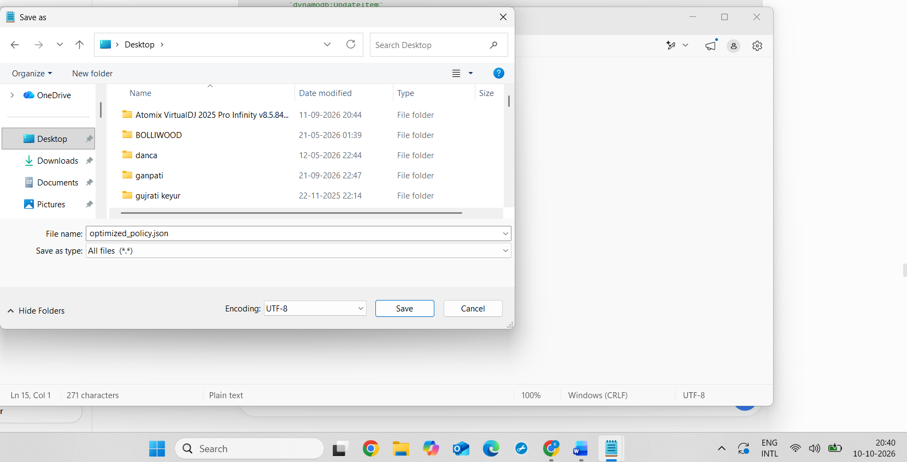
Screenshot : The optimized IAM policy successfully saved as optimized_policy.json.

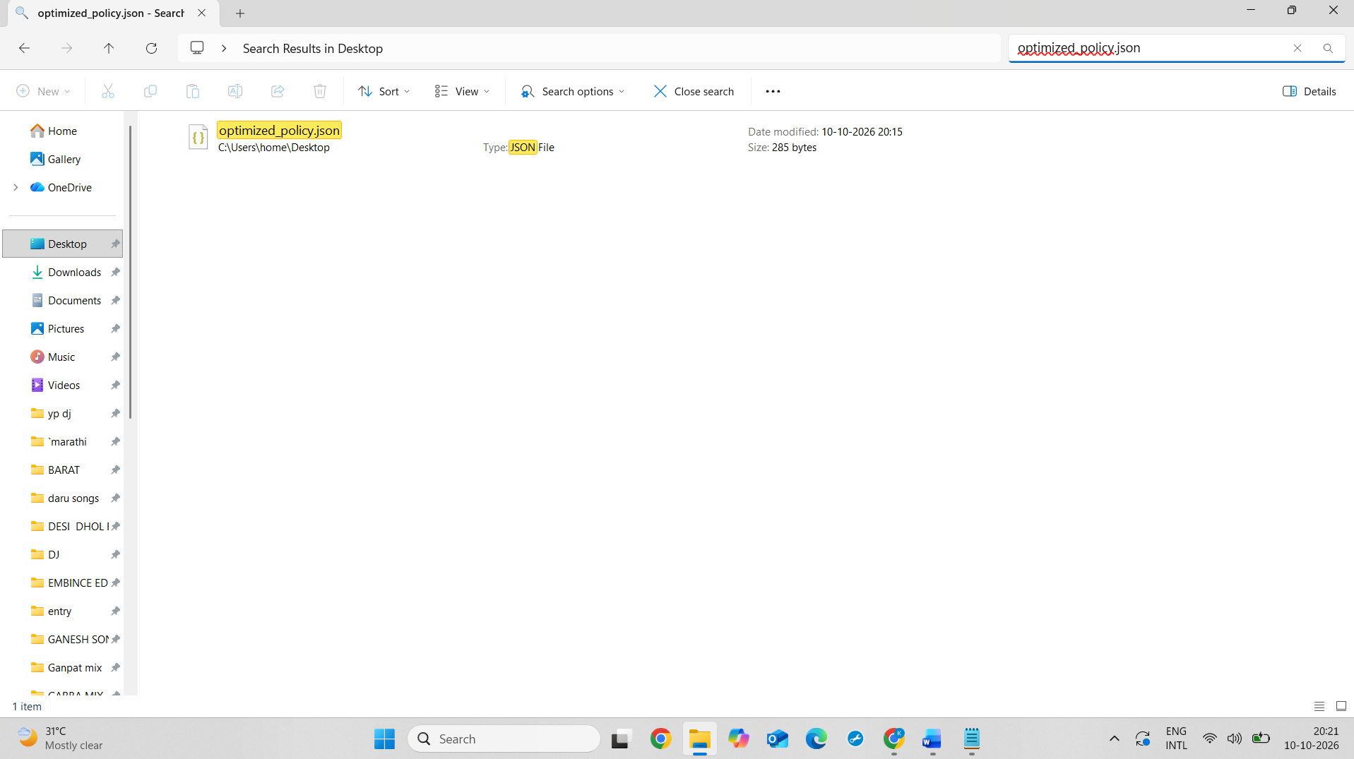
3.
Review an IAM policy that grants full S3 access to a group called 'AppUsers' and modify it so users can only read from a specific bucket named 'user-uploads', not write or delete files.<br><br><em><strong>Hint:</strong> Use the 'Action' and 'Resource' fields to restrict permissions.</em>
ANS :
To modify an IAM policy for the AppUsers group so that users can only read files from the Amazon S3 bucket named user-uploads.
AWS IAM policies control access to AWS resources by specifying the permitted actions and resources. A policy that grants full S3 access provides more permissions than users may need.
To follow the principle of least privilege, the policy was modified to allow only s3:ListBucket and s3:GetObject on the specified user-uploads bucket. The s3:ListBucket action allows users to list bucket contents, while s3:GetObject allows them to read or download files.
Write and delete permissions were not included. Therefore, this policy does not grant users permission to upload or delete objects.
Conclusion
The IAM policy was restricted to read-only access for the user-uploads bucket. This reduces unnecessary permissions and improves security by following the principle of least privilege.
Screenshot : Modified IAM policy restricting the AppUsers group to read-only access on the user-uploads S3 bucket, without write or delete permissions.

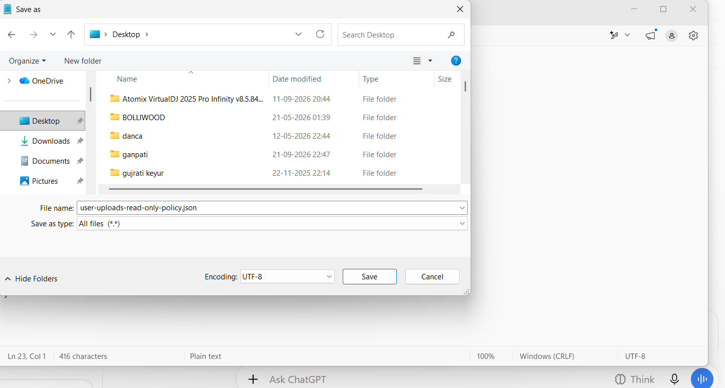
Screenshot : Revised read-only IAM policy saved as user-uploads-read-only-policy.json.

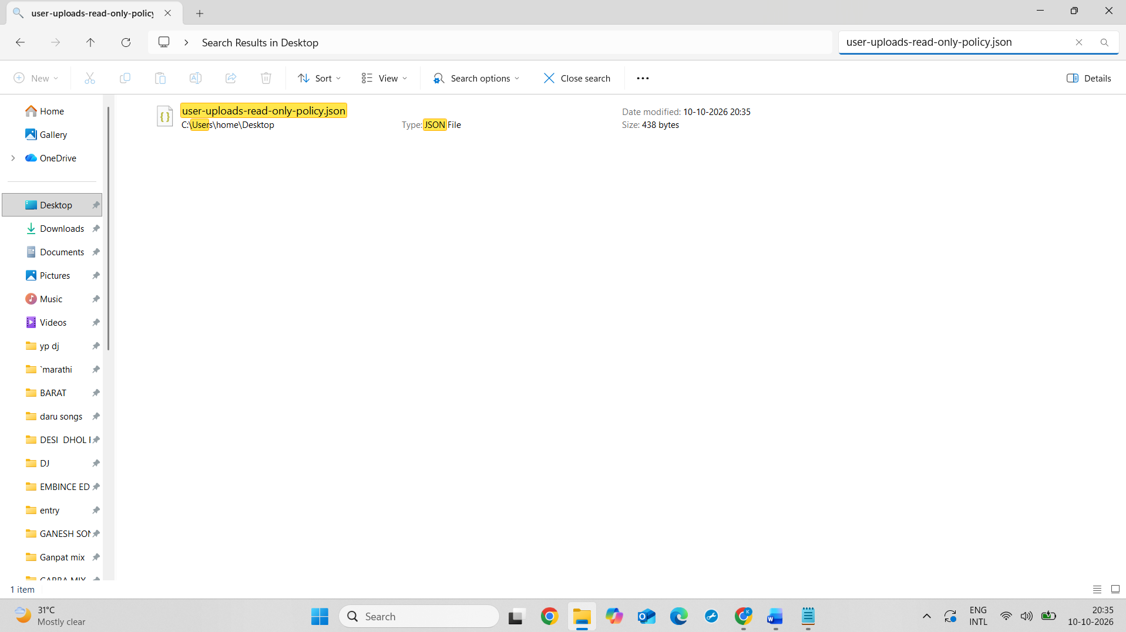
4.
Write a checklist of 5 steps you would follow to regularly review IAM policies for a movie ticket booking app (like BookMyShow), including how you would identify unused permissions and revoke them.
ANS :
IAM Policy Review Checklist for a Movie Ticket Booking App :
1. Review IAM Users, Groups, and Roles
- Check all IAM users, groups, and roles used by the application.
- Verify that permissions match responsibilities, such as booking tickets, processing payments, and managing movie listings.
- Remove access for inactive users or services that are no longer required.
2. Examine Existing IAM Policies
- Review attached and inline policies regularly.
- Identify broad permissions such as Action: "*" or unrestricted resource access using Resource: "*".
- Replace broad permissions with specific actions and resources wherever possible.
3. Identify Unused Permissions
- Use AWS IAM Access Analyzer and last-accessed information to review service and action usage.
- Examine AWS CloudTrail logs to identify which permissions are actually being used.
- Investigate permissions that have not been used for an appropriate period before deciding whether they can be removed.
4. Revoke Unnecessary Permissions
- Remove unused or excessive permissions after confirming that they are not required.
- For example, a ticket booking service may need permission to read movie details and create bookings, but it should not automatically receive permission to delete all customer records.
- Test policy changes in a safe environment to ensure that essential booking and payment functions continue to work.
5. Schedule Regular Audits and Monitor Changes
- Review IAM policies monthly or after major application changes.
- Monitor access and policy changes using AWS CloudTrail.
- Document the review results, permissions removed, and any exceptions approved by the administrator.
Conclusion
Regular IAM policy reviews help protect customer information, booking records, and payment-related resources. Identifying unused permissions and removing unnecessary access follows the principle of least privilege and improves the overall security of the movie ticket booking application.

5.
Use ChatGPT or another AI tool to analyze a provided IAM policy snippet and suggest at least two improvements to enhance security following best practices.<br><br><em><strong>Hint:</strong> Paste the policy into the AI tool and ask for recommendations based on least privilege and regular review.</em>`
ANS :
To analyze a sample AWS IAM policy using an AI tool and suggest security improvements based on the principle of least privilege.
1. Sample IAM Policy
The following policy grants full Amazon S3 access to all S3 resources.
{
"Version": "2012-10-17",
"Statement": [
{
"Effect": "Allow",
"Action": "s3:*",
"Resource": "*"
}
]
}
2. Problems Identified
The policy grants excessive permissions because s3:* allows all S3 actions and Resource: "*" applies to all S3 resources. This may allow users to perform unnecessary actions, including deleting objects or changing bucket configurations.
3. Recommended Security Improvements
Improvement 1: Apply the Principle of Least Privilege
Replace s3:* with only the specific actions required by the user, such as s3:GetObject for reading files or s3:PutObject for uploading files. Avoid granting delete permissions unless required.
Improvement 2: Restrict Access to Specific Resources
Replace Resource: "*" with the ARN of the required S3 bucket and its objects. This limits access to the resources necessary for the user's work.
Improvement 3: Review Permissions Regularly
Use AWS IAM Access Analyzer, service last-accessed information, and AWS CloudTrail logs to identify unused permissions. Remove unnecessary permissions after confirming they are no longer required.
4. Improved IAM Policy Example
The following policy allows users to read objects from the user-uploads bucket only.
{
"Version": "2012-10-17",
"Statement": [
{
"Sid": "AllowReadOnlyAccessToOneBucket",
"Effect": "Allow",
"Action": [
"s3:GetObject"
],
"Resource": "arn:aws:s3:::user-uploads/*"
}
]
}
This policy allows reading objects in the specified bucket without granting upload or delete permissions. It does not grant permission to list the bucket's contents.
5. Conclusion
The AI analysis identified excessive permissions in the original IAM policy. Restricting actions, limiting access to specific resources, and reviewing permissions regularly help improve security and reduce the risk of unauthorized access.

